**Applied Statistics - Lab 3**

**Date of performance:** 26-08-2021

**Date of Submission:** 1-09-2021

**SAP Id:** 500083382

**Name:** Anurag Singh

**Batch:** AI&ML B2

**___________________________________________________________________________**

**Topic:** Mean and Standard Deviation

**Problem:**

1. Generate a random sample with Mean = 5, Standard Deviation = 2
2. Plot the distribution
3. Give the summary statistics

**Code:**

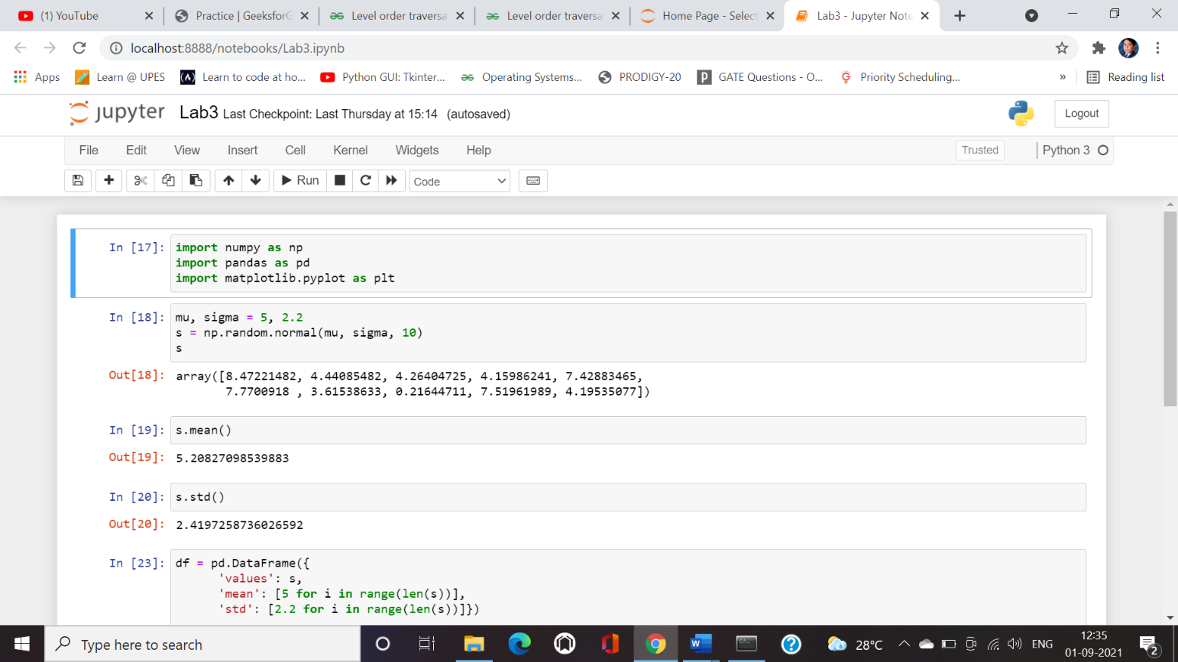

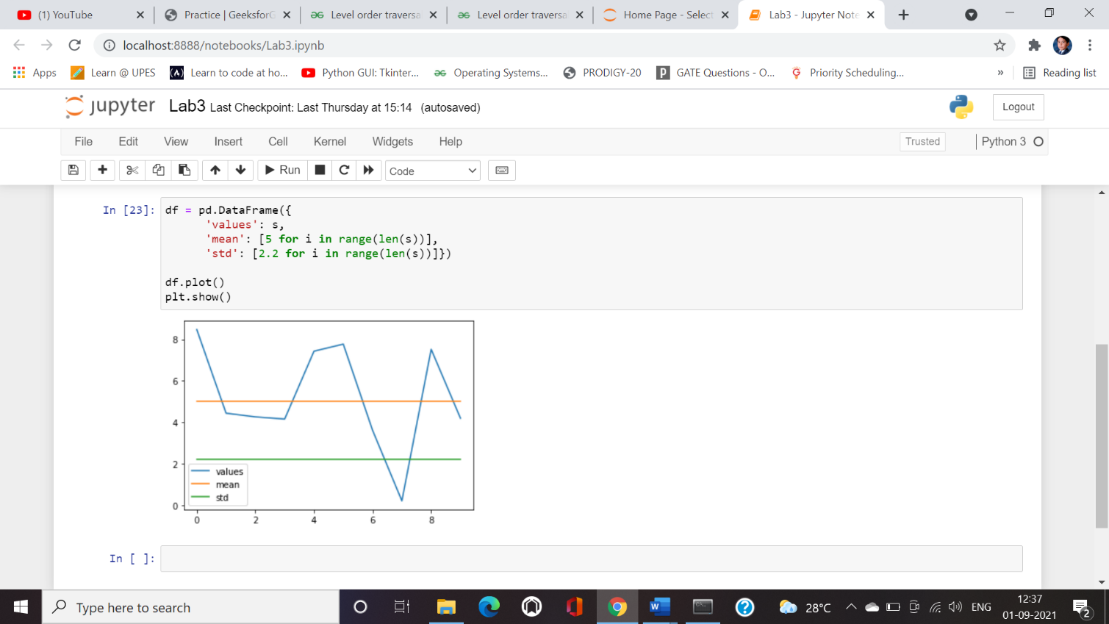

**Summary Statistics:**

In the above problem statement, we have used summary statistics: Graphs, measures of spread and measures of location.

* Measures of Location tell us where our data is centred, or where a [trend](https://www.statisticshowto.com/trend-analysis/) lies. We used mean() which is equivalent to calculating the average in data.

Measures of Spread tells us (perhaps not surprisingly!) how spread out or varied your data set is. This can be important information.